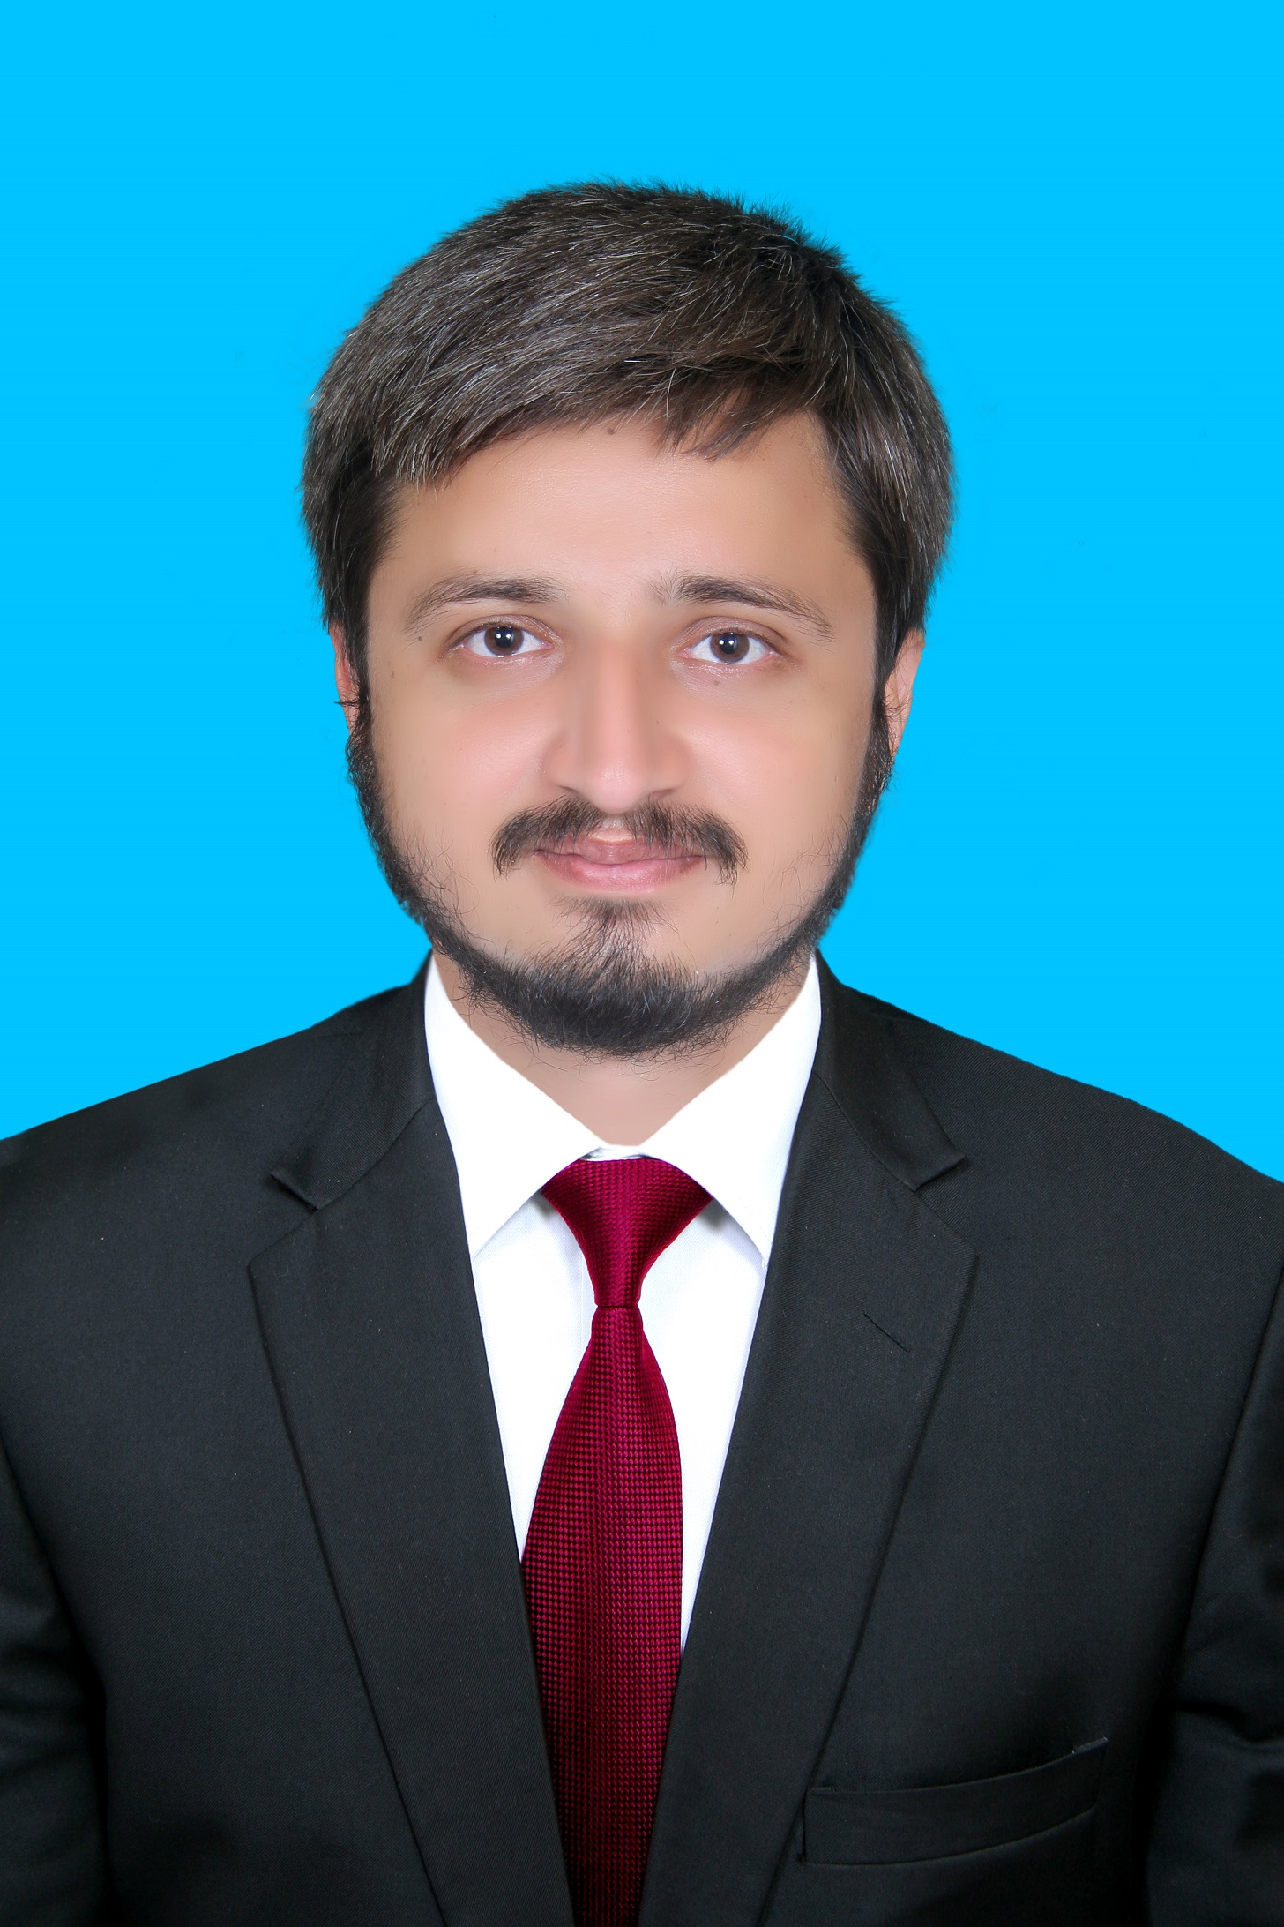

Contact

**Address:**

Khanewal; Punjab

**Phone:**

+92 303 7385017

**Email:**

[chaudharyabdurrehman10@gmail.com](mailto:chaudharyabdurrehman10@gmail.com)

Languages

English – **Fluent**

Urdu – **Fluent**

|  |  |
| --- | --- |
| Hobbies |  |

* Reading
* Writing

**Education**

**Graduation** | **Computer Science** | **MNS University of Agriculture Multan** | **2.69/4.00** | **1st Division**

Certifications

Programming Languages: **JavaScript, HTML5, PHP OOP, CSS, SQL, MySQL**

Skill Highlights

|  |  |
| --- | --- |
| * Programming Languages: **C, C#, Python** * Database Management: **SQL, SQLite** * Complex problem solver | * Creative design * Innovative * Service-focused |

# Experience

* **biometric attendance system:** Developed and implemented C programming solution for a variety of projects including embedded system and software development such as biometric attendance system
* Develop project concepts and maintain optimal workflow.
* developed C program for large scale and real-time data analysis
* **Inventory Management System**: Developed a C# application for tracking inventory levels and managing product.
* Developed backend functionality to store and manipulate inventory data in a SQL database, optimizing queries for efficient data retrieval and management
* Integrated barcode scanning functionality to streamline inventory input processes, reducing manual data entry errors.
* **Data Analysis Tool:** Created a Python script to analyze sales data and generate reports for business insights
* Designed and implemented the tool's functionality using Python programming language, leveraging libraries such as Pandas, NumPy, and Matplotlib for data manipulation, analysis, and visualization.
* Developed user-friendly command-line interface (CLI) for easy interaction and input of data analysis parameters, enhancing usability and accessibility.

# Summary

# Innovative and analytical Software Developer with professional experience in employing C language principles to build software applications. Computer Science Graduate highly skilled in C# and Python coding with demonstrated expertise improving workflow efficiency and driving user engagement. Proficient in system design and technical specification. A self-motivated individual with strong adaptability and problem-solving skills. Passionate about producing high-quality software solutions

ABDUR REHMAN